LAB 1

23K-0634

Q1.

#include<iostream>

using namespace std;

class bankAccount{

    public:

    int balance=0;

    bankAccount(){};

    bankAccount(int bal){

        balance = bal;

    }

    void print(){

        cout<<"Bank balance is: "<<balance<<endl;

    }

};

int main()

{

    //a

    bankAccount account1;

    account1.print();

    //b

    bankAccount account2(1000);

    account2.print();

    //c

    bankAccount account3 = account2;

    account3.balance = account3.balance - 200;

    account3.print();

    account2.print();

    return 0;

}

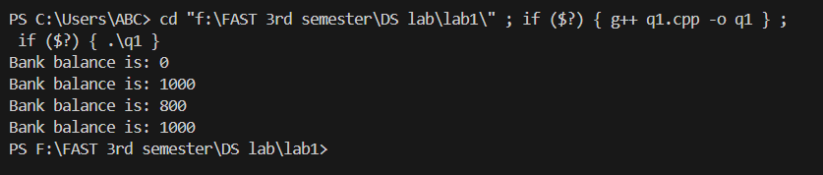

Q2.

#include <iostream>

using namespace std;

class Exam{

    private:

    string name;

    string date;

    int score;

    public:

    Exam(){};

    Exam(string n, string d,int s):name(n),date(d),score(s){};

    void display(){

        cout<<"Name: "<<name<<endl;

        cout<<"Date: "<<date<<endl;

        cout<<"Score: "<<score<<endl;

    }

};

int main()

{

    Exam exam1("rayyan","20/08/24",99);

    Exam exam2 = exam1;

    exam1.display();

    exam2.display();

    //shallow copy done.

    //issue: if any pointer used, it does not copy the data of the pointer, hence mempory leaking and improper/incomplete copy of class.

    return 0;

}

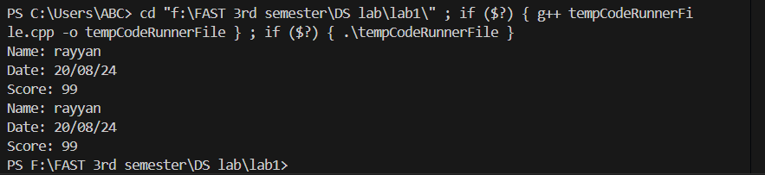

Q3.

#include<iostream>

using namespace std;

class Document{

    string \*text;

    public:

    Document(){};

    void settext(string txt){

        text = new string(txt);

    }

    Document(string data){

        text = new string(data);

    }

    ~Document(){

        delete text;

    }

    Document(Document &doc2){

        text = new string(\*doc2.text);      //Deep copy

    }

    Document& operator= (Document &doc2) {

        text = new string(\*doc2.text);      //assignment operator

        return \*this;

    }

    void print(){

        cout<<"The text of document is: "<<\*text<<endl;

    }

};

int main()

{

    Document doc1("Rayyan ur rehman");

    Document doc2 = doc1;

    Document doc3("sufyan ur rehman");

    doc3 = doc1;

    doc1.print();

    doc2.print();

    doc3.print();

    doc1.settext("azlaan ur rehman");       //checking after modifying original document.

    doc1.print();

    doc2.print();

    doc3.print();

    return 0;

}

